Pentagonal Antiprism
# Source: AI Source: Provided by: [Data Path: Persons Table -> ID Column: 1, Name_En Column: Motasem Essam] -> From: [ChatGPT] on [7/25/2026]
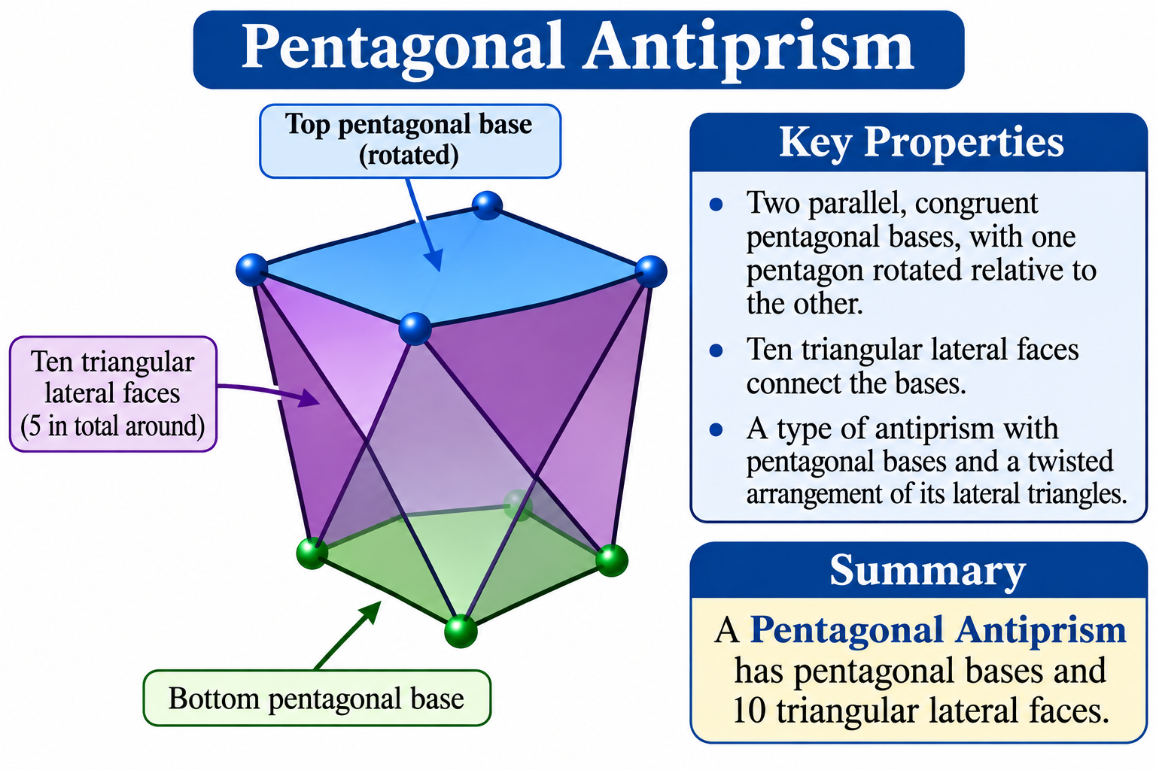

Definition
# Source: AI Source: Provided by: [Data Path: Persons Table -> ID Column: 1, Name_En Column: Motasem Essam] -> From: [ChatGPT] on [7/25/2026]
A Pentagonal Antiprism is a polyhedron consisting of two parallel, congruent pentagonal bases, with one pentagon rotated relative to the other. The bases are connected by ten triangular lateral faces.
It is a type of antiprism with pentagonal bases and a twisted arrangement of its lateral triangles.
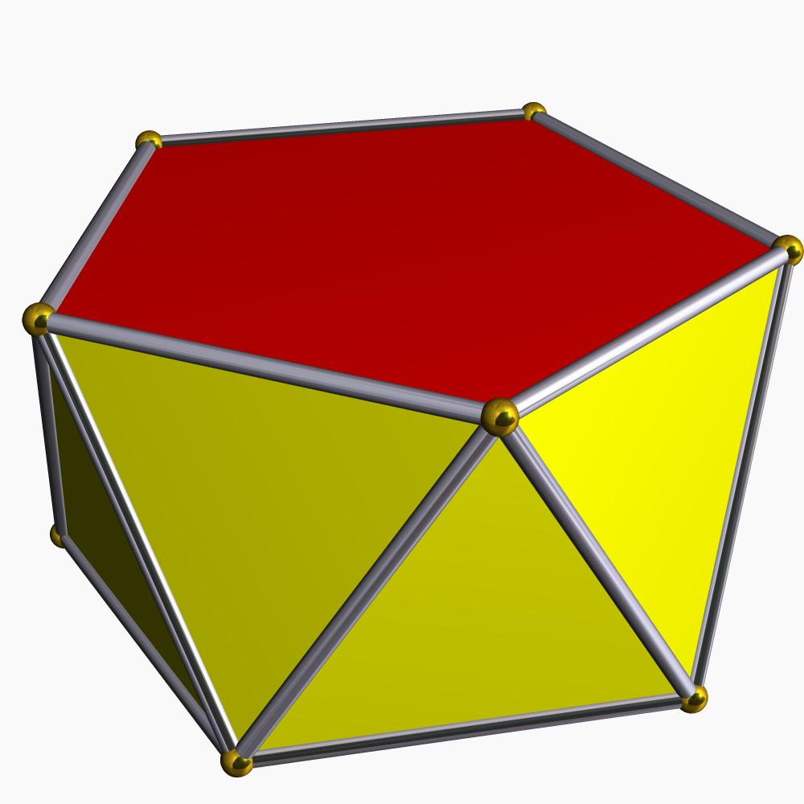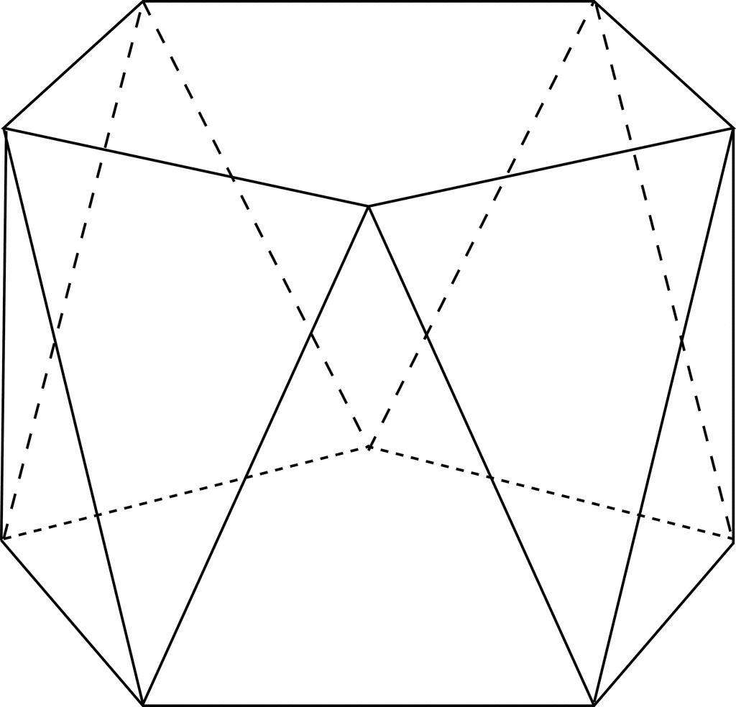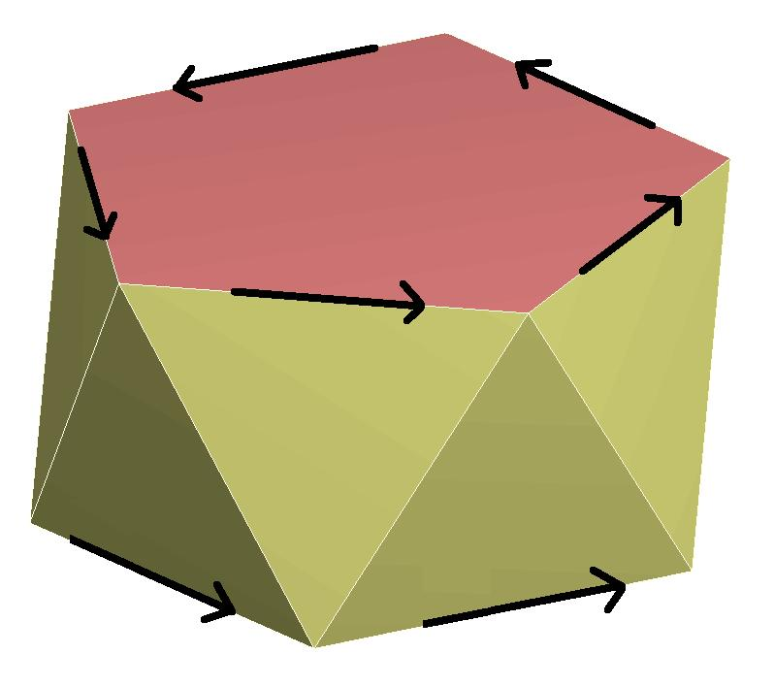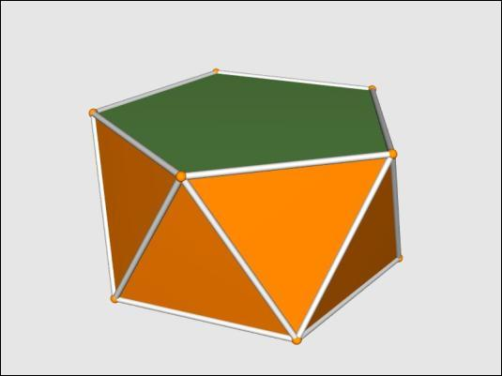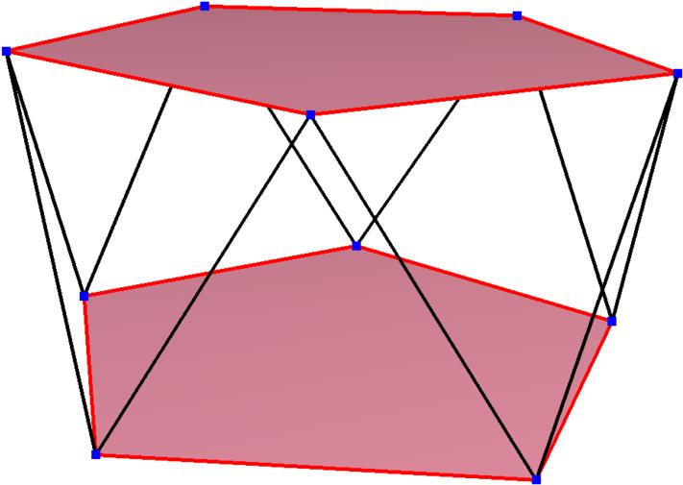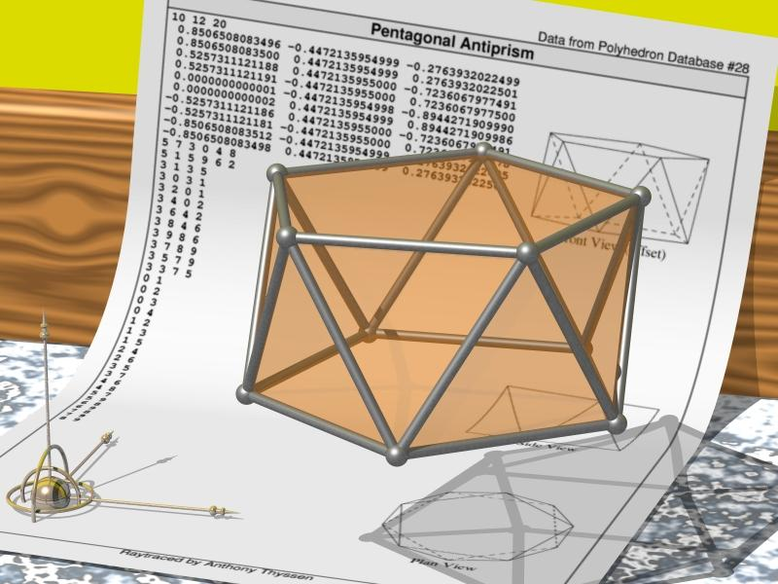

Geometric Structure
# Source: AI Source: Provided by: [Data Path: Persons Table -> ID Column: 1, Name_En Column: Motasem Essam] -> From: [ChatGPT] on [7/25/2026]
The pentagonal antiprism consists of:
- Upper Pentagonal Base: A pentagon forming the top face.
- Lower Pentagonal Base: A congruent pentagon forming the bottom face, rotated relative to the upper base.
- Triangular Lateral Faces: Ten triangles connecting the two pentagonal bases.
- Vertices: Ten vertices, with five on each base.
- Edges: Twenty edges connecting the vertices.

Face Composition
# Source: AI Source: Provided by: [Data Path: Persons Table -> ID Column: 1, Name_En Column: Motasem Essam] -> From: [ChatGPT] on [7/25/2026]
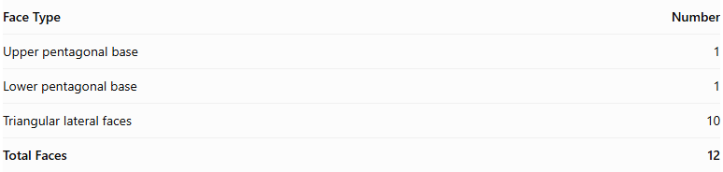
Face Type | Number
Upper pentagonal base | 1
Lower pentagonal base | 1
Triangular lateral faces | 10
Total Faces | 12

Mathematical Properties
# Source: AI Source: Provided by: [Data Path: Persons Table -> ID Column: 1, Name_En Column: Motasem Essam] -> From: [ChatGPT] on [7/25/2026]
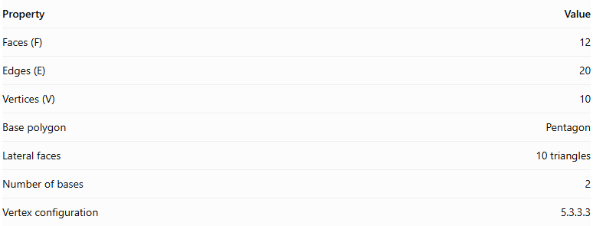
Property | Value
Faces (F) | 12
Edges (E) | 20
Vertices (V) | 10
Base polygon | Pentagon
Lateral faces | 10 triangles
Number of bases | 2
Vertex configuration | 5.3.3.3
Euler's formula:
$$V-E+F=2$$
$$10-20+12=2$$
Regular Pentagonal Antiprism
In a regular pentagonal antiprism:
- Both pentagonal bases are regular and congruent.
- The upper and lower bases are rotated relative to each other, typically by ${36}^{∘}$.
- The ten lateral triangular faces are equilateral.
- The vertices have the same local arrangement.

Constructing Pentagonal Antiprism in Solid Geometry

Geometric Instruments Used
# Source: AI Source: Provided by: [Data Path: Persons Table -> ID Column: 1, Name_En Column: Motasem Essam] -> From: [ChatGPT] on [7/25/2026]
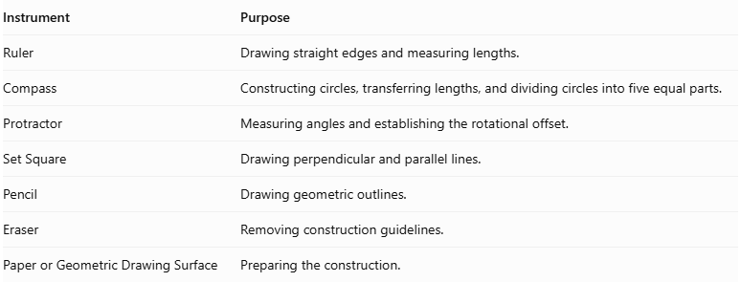
Instrument | Purpose
Ruler | Drawing straight edges and measuring lengths.
Compass | Constructing circles, transferring lengths, and dividing circles into five equal parts.
Protractor | Measuring angles and establishing the rotational offset.
Set Square | Drawing perpendicular and parallel lines.
Pencil | Drawing geometric outlines.
Eraser | Removing construction guidelines.
Paper or Geometric Drawing Surface | Preparing the construction.

Instrument-Based Construction Procedures
# Source: AI Source: Provided by: [Data Path: Persons Table -> ID Column: 1, Name_En Column: Motasem Essam] -> From: [ChatGPT] on [7/25/2026]
The pentagonal antiprism can be constructed using geometric instruments and classical geometric drawing techniques, without using coordinate-based construction.

Constructing the Lower Pentagonal Base
# Source: AI Source: Provided by: [Data Path: Persons Table -> ID Column: 1, Name_En Column: Motasem Essam] -> From: [ChatGPT] on [7/25/2026]
- Draw a circle using a compass.
- Divide the circle into five equal angular sections.
- Each central angle measures:
$$\frac{{360}^{∘}}{5}={72}^{∘}$$
- Mark the five vertices on the circumference.
- Connect consecutive vertices using a ruler to form a regular pentagon.
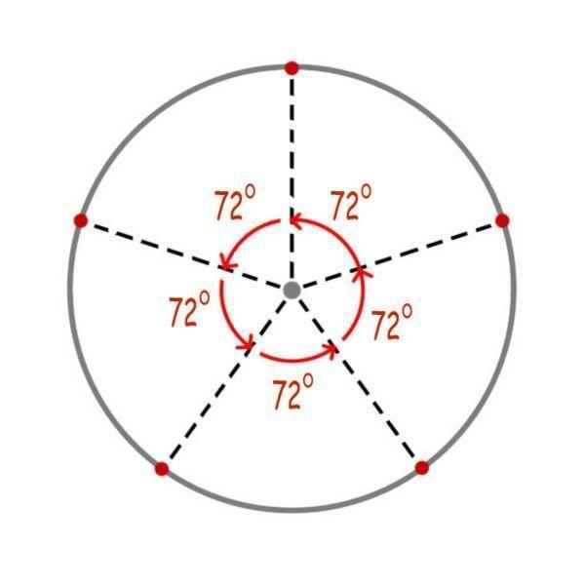

Constructing the Upper Pentagonal Base
# Source: AI Source: Provided by: [Data Path: Persons Table -> ID Column: 1, Name_En Column: Motasem Essam] -> From: [ChatGPT] on [7/25/2026]
- Draw a second regular pentagon congruent to the lower base.
- Position it above and parallel to the lower pentagon.
- Rotate its orientation by half the central angle:
$$\frac{{72}^{∘}}{2}={36}^{∘}$$
- Maintain the same side length and geometric proportions.

Connecting the Two Bases
# Source: AI Source: Provided by: [Data Path: Persons Table -> ID Column: 1, Name_En Column: Motasem Essam] -> From: [ChatGPT] on [7/25/2026]
- Connect each vertex of the lower pentagon to the two nearest vertices of the upper pentagon.
- Repeat the connections around the entire solid.
- Ensure the connecting edges alternate between the upper and lower bases.
- Form ten triangular lateral faces.

Completing the Solid
# Source: AI Source: Provided by: [Data Path: Persons Table -> ID Column: 1, Name_En Column: Motasem Essam] -> From: [ChatGPT] on [7/25/2026]
- Complete all ten triangular lateral faces.
- Emphasize the visible edges.
- Use dashed lines for hidden edges when necessary.
- Verify that both pentagonal bases are congruent and parallel.
- Check that the upper base has the correct 36° rotational offset.
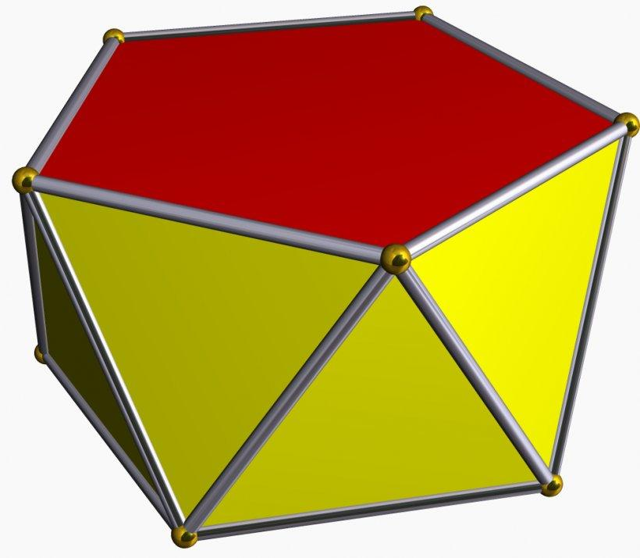

Constructing a Net
# Source: AI Source: Provided by: [Data Path: Persons Table -> ID Column: 1, Name_En Column: Motasem Essam] -> From: [ChatGPT] on [7/25/2026]
A net of a pentagonal antiprism contains:
- Two congruent pentagonal bases.
- Ten triangular lateral faces.
- A connected arrangement of faces with matching edge lengths and correct face adjacency.
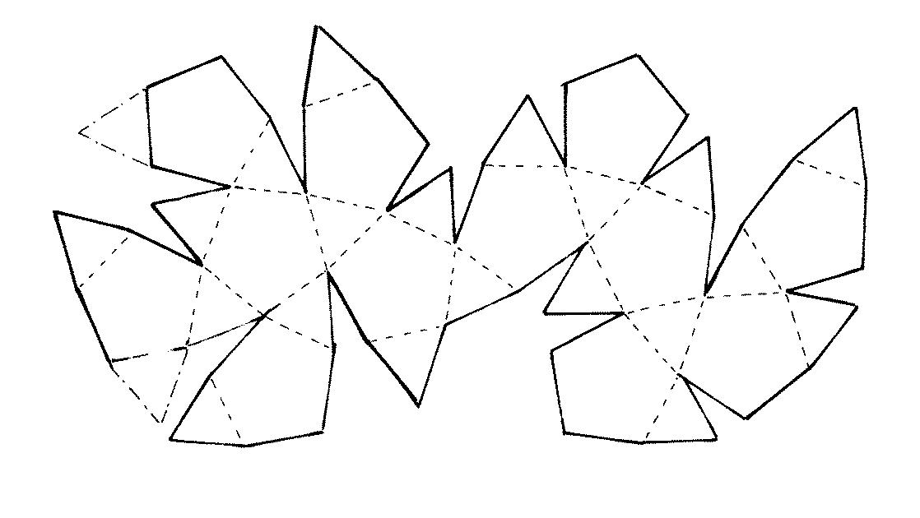

Key Points
# Source: AI Source: Provided by: [Data Path: Persons Table -> ID Column: 1, Name_En Column: Motasem Essam] -> From: [ChatGPT] on [7/25/2026]
- It has two parallel pentagonal bases.
- The bases are rotated relative to each other.
- It has ten triangular lateral faces.
- It contains 12 faces, 20 edges, and 10 vertices.
- Its regular form is a uniform polyhedron.

Classification
# Source: AI Source: Provided by: [Data Path: Persons Table -> ID Column: 1, Name_En Column: Motasem Essam] -> From: [ChatGPT] on [7/25/2026]
Solid Geometry
└── Types of Solids
└── Antiprism
└── Types of Antiprisms
└── Pentagonal Antiprism
├── Upper Pentagonal Base
├── Lower Pentagonal Base
└── Triangular Lateral Faces

Conclusion
# Source: AI Source: Provided by: [Data Path: Persons Table -> ID Column: 1, Name_En Column: Motasem Essam] -> From: [ChatGPT] on [7/25/2026]
A Pentagonal Antiprism is an antiprism with two congruent pentagonal bases and ten triangular lateral faces, arranged in a twisted configuration.

